- ADVANCED GIS OPERATIONS
  - Nearest Neighbor Analysis
Step 1: Add Delimited Text Layer “signif.txt file”. Since this is a tab-delimited file, choose Tab as the File format. The X field and Y field would be auto-populated. Click OK. As the earthquake dataset has Latitude/Longitude coordinates, it will be imported with the default CRS of EPSG: 4326. Verify that is the case in the bottom-right corner. Let’s also open the ne_10m_populated_places_simple.zip file.
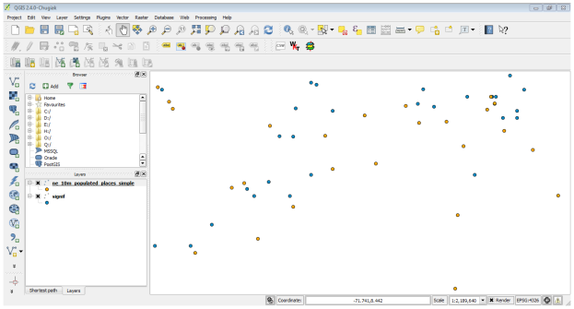
Step 2: We need a way to find out the nearest point from the populated places layer for each of the points in the earthquake layer. Go to Vector ‣ Analysis Tools ‣ Distance Matrix. Here select the earthquake layer signif as the Input point layer and the populated places ne_10m_populated_places_simple as the target layer. You also need to select a unique field from each of these layers which is how your results will be displayed. In this analysis, we are looking to get only 1 nearest point, so check the Use only the nearest (k) target points, and enter 1 Name your output file matrix.csv, and click OK. Once the processing finishes, click Close
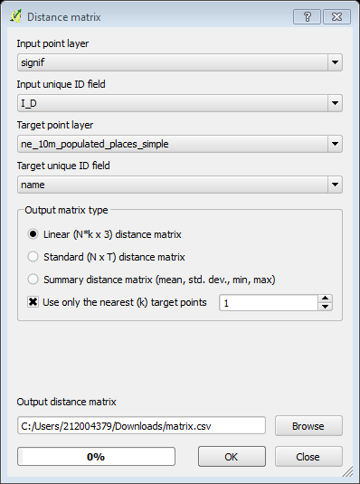

Step 3: Browse to the newly created matrix.csv file. Since this file is just text columns, select No geometry (attribute only table) as the Geometry definition. Click OK. You will see the CSV file loaded as a table. Open attribute table. The Input ID field contains the field name from the Earthquake layer. The Target ID field contains the name of the feature from the Populated Places layer that was the closest to the earthquake point. The Distance field is the distance between the 2 points.
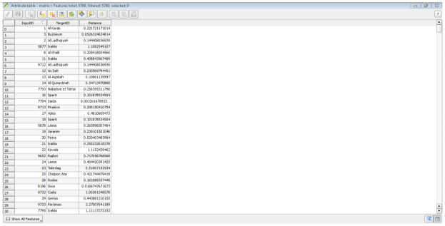

Step 4: This is very close to the result we were looking for. For some users, this table would be sufficient. However, we can also integrate this results in our original Earthquake layer using a Table Join. open earthquake layer properties. Go to the Joins tab and click on the + button. We want to join the data from our analysis result to this layer. We need to select a field from each of the layers that has the same values. Select matrix as the Join layer` and InputID as the Join field. The Target field would be I_D. Leave other options to their default values and click OK. You will see the join appear in the Joins tab. Click OK.

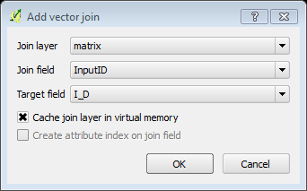
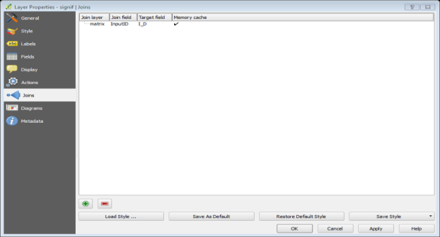
Step 5: Now open the attribute table of the signif layer; you will see that for every Earthquake feature, we now have an attribute which is the nearest neighbor (closest populated place) and the distance to the nearest neighbor. We will now explore a way to visualize these results. First, we need to make the table join permanent by saving it to a new layer and name the output layer as “earthquake_with_places.shp”.
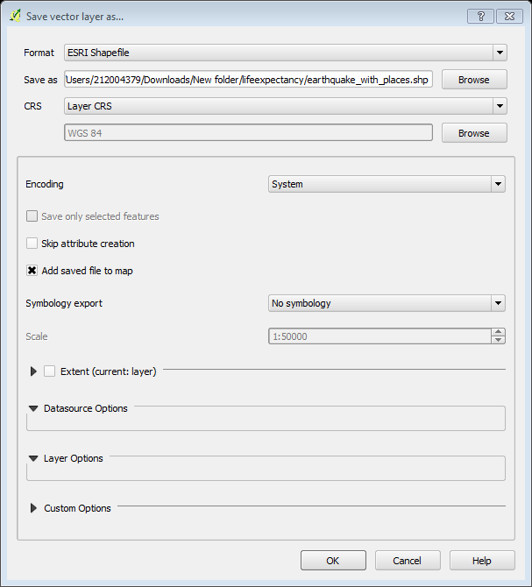

Step 6: Once the new layer is loaded, you can turn off the visibility of the signif layer. As our dataset is quite large, we can run our visualization analysis on a subset of the data. QGIS has a neat feature where you can load a subset of features from a layer without having to export it to a new layer. Open earthquake_with_places layer properties. In the General tab, scroll down to the Feature subset section. Click Query Builder. For this lesson, we will visualize the earthquakes and their nearest populated places for Mexico. Enter the following expression in the Query Builder dialog. You will see that only the points falling within Mexico will be visible in the canvas. Let’s do the same for the populated places layer.
"COUNTRY" = 'MEXICO'
"adm0name" = 'Mexico'
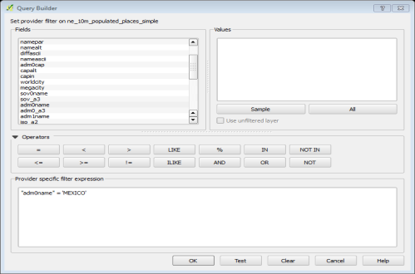
Step 7: Now we are ready to create our visualization using a plugin named MMQGIS. Select ne_10m_populated_places_simple as the Hub Point Layer and name as the Hub ID Attribute. Similarly, select earthquake_with_places as the Spoke Point Layer and matrix_Tar as the Spoke Hub ID Attribute. The hub lines algorithm will go through each of earthquake points and create a line that will join it to the populated place which matches the attribute we specified. Click Browse and name the Output Shapefile as earthquake_hub_lines.shp. Click OK to start the processing.
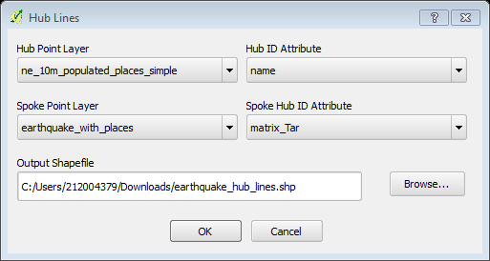

Once the processing is done, you will see the earthquake_hub_lines layer loaded in QGIS. You can see that each earthquake point now has a line that connects it to the nearest populated place.
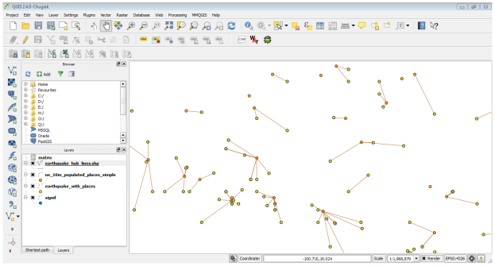

  - Sampling Raster Data using Points or Polygons
Step: Add Raster Layer downloaded “us.tmax_nohads_ll_{YYYYMMDD}_float.tif file”. Once the layer is loaded, select the Identify tool and click anywhere on the layer. You will see the temperature value in celsius as the value or Band 1 at that location. Now unzip the downloaded 2013_Gaz_ua_national.zip file and extract the 2013_Gaz_ua_national.txt file on your disk. Go to Layer ‣ Add Delimited Text Layer and the 2013_Gaz_ua_national.txt. Choose Tab under Custom delimiters. The point coordinates are in Latitude and Longitude, so select INTPTLONG as X field and INTPTLAT as Y field. Check the Use spatial index box and click OK.
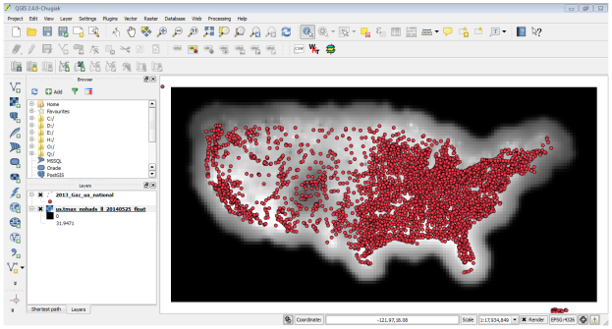

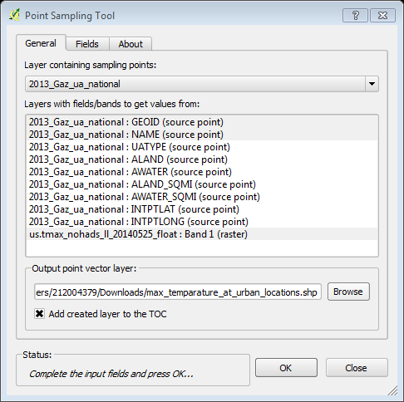
Step 2: Now we are ready to extract the temperature values from the raster layer. Install the Point Sampling Tool plugin. In the Point Sampling Tool dialog, select 2013_Gaz_ua_national as the Layer containing sampling points. We must explicitly pick the fields from the input layer that we want in the output layer. Choose GEOID and NAME fields from the 2013_Gaz_ua_national layer. We can sample values from multiple raster band at once, but since our raster has only 1 band, choose the “us.tmax_nohads_ll_{YYYYMMDD}_float: Band 1”. Name the output vector layer as “max_temparature_at_urban_locations.shp”. Click the OK to start the sampling process. Click Close once the process finishes.

Step 3: You will see a new layer max_temparature_at_urban_locations loaded in QGIS. Use the Identify tool to click on any point to see the attributes. You will see the us.tmax_no field - which contains the raster pixel value at the location of the point. First part of our analysis is over. Let’s remove the max_temparature_at_urban_locations and 2013_Gaz_ua_national layers. Right click the “tl_2013_us_county layer” and select Save As. In the Save Vector layer as dialog, name the output file as “counties.shp”. Choose Selected CRS from the CRS dropdown menu. Click Browse and select WGS 84 as the CRS. Check the Add saved file to map and click OK. A new layer named counties will be added to QGIS.
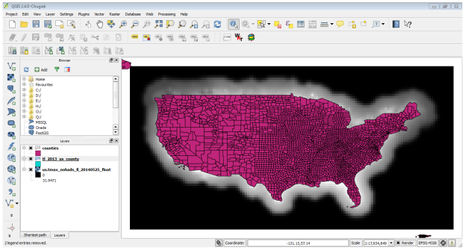
Step 4: Enable the Zonal Statistics Plugins. This is a core plugin so it is already installed. Go to Raster ‣ Zonal statistics ‣ Zonal statistics. Select “us.tmax_nohads_ll_{YYYYMMDD}_float” as the Raster layer and countries as the Polygon layer containing the zones. Enter ZS_ as the Output column prefix. Click OK. The analysis may take some time depending on the size of the dataset

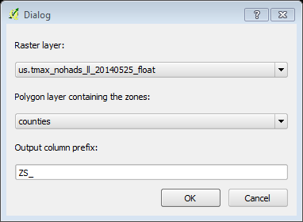

Step 5: Once the processing finishes, select the counties layer. Use the Identify tool and click on any county polygon. You will see three new attributes added to the layer: ZS_count, ZS_mean and ZS_sum. These attributes contain the count of raster pixels, mean of raster pixel values and sum of raster pixel values respectively. Since we are interested in average temperature, the ZS_mean field will be the one to use.
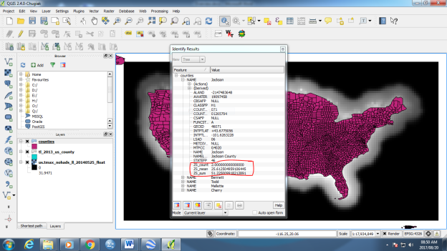

Step 6: Let’s style this layer to create a temperature map. Form previous excises we have dealt with basic vector styling. Therefore, the procedure to style this layer is the same as the previous. Choose Graduated style and select ZS_mean as the Column and classify. You will see the county polygons styled using average maximum temperature extracted from the raster grid
