- BASICS GIS OPERATIONS
  - Basic Vector Styling
To create a map, one has to style the GIS data and present it in a form that is visually informative. There are a large number of options available in QGIS to apply different types of symbology to the underlying data. In this part, we will explore some basics of styling. We will style a vector layer to show life expectancy in different countries of the world.
Other skills you will learn
- View the attribute table of a vector layer.
A vector layer to showing life expectancy in different countries of the world according to low (Red), medium (Yellow) and high (Green)
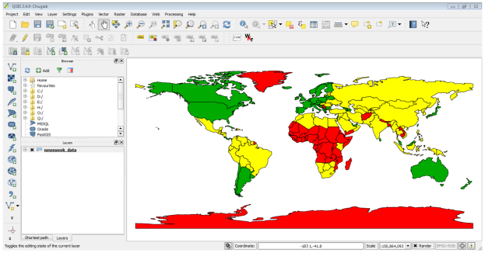

Step 1: Upload the “lifeexpectancy.zip” to QGIS. Next you will be prompted for choosing the CRS. Select WGS84 EPSG: 4326 as the Coordinate Reference System (CRS). The shapefile contained within the zip file is now loaded and you can see the default style applied to it.
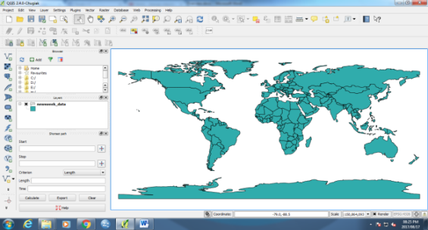

Step 2: Open Attribute Table, the field LIFEXPCT is the attribute we want to use in styling. Right click on the layer again and choose Properties. The various styling options are located in the Style tab of the Properties dialog. Clicking on the drop-down button in the Style dialiog, you will see there are five options available - Single Symbol, Categorized, Graduated, Rule Based and Point displacement. We will explore the first three in this tutorial. Select Single Symbol. This option allows you to choose a single style that will be applied to all the features in the layer. Choose the dotted pattern fill and click OK.
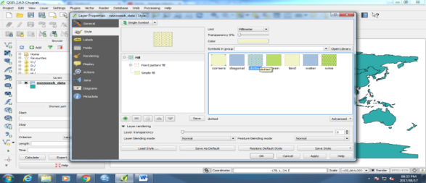
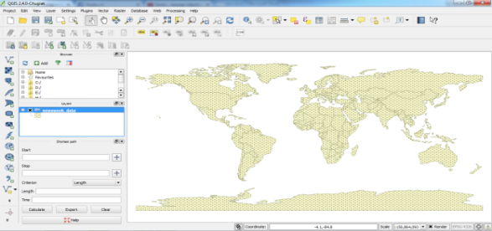
Step 3: You will see a new style applied to the layer with the fill pattern you chose.

Step 4: To explore another styling option. Right-click the layer again and choose Properties. This time choose Categorized from the Style tab. Categorized means the features in the layer will be shown in different shades of a color based on unique values in an attribute field. Choose LIFEXPCT value as the Column. Choose a color ramp of your choice and click Classify at the bottom. Click OK
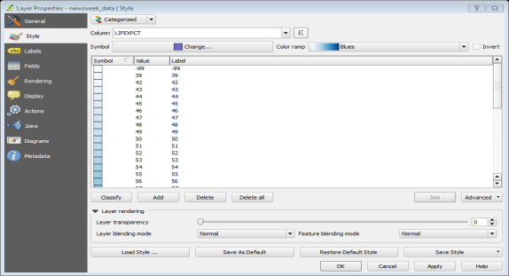
Step 5: This representation of the data is more useful and clearly shows how life expectancy in developed countries vs. developing countries. Lighter blue shades means lower life expectancy and darker blue shades means higher life expectancy
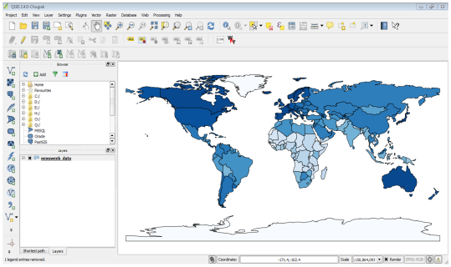

Step 6: Now we explore the Graduated symbology type in the Style dialog now. Graduated symbology type allows you to break down the data in a column in unique classes and choose a different style for each of the classes. We can think of classifying our life expectancy data into 3 classes, LOW, MEDIUM and HIGH. Choose LIFEXPCT as the Column and choose 3 as the classes. You will see there are many Mode options available. To keep things simple, let’s use the Quantile method.
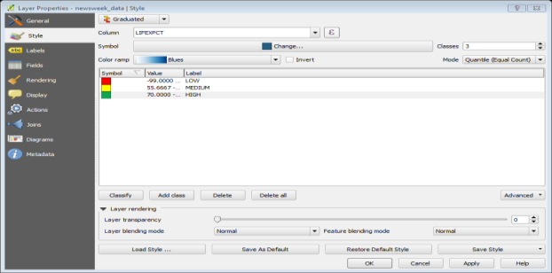

  - Calculating Line Lengths and Statistics
Overview of the task
We will use a polyline shapefile of railroads in North America and try to determine the total length of railroads in the United States. At this stage we assume that you know how to upload a data (Vector and Raster) on QGIS, open attribute table, Open properties, styling and selecting and deselecting.
Other skills Learned
• Using expressions to select features.
• Re-projecting a layer from Geographic to Projected Coordinate Reference System (CRS).
• Viewing statistics for values of an attribute in a layer
Step 1: Upload the “ne_10m_railroads_north_america.zip” file. Since we want to calculate line lengths only for United States railroads, we need to select the lines that fall in the United States. Right click on the layer and select Open Attribute Table. The layer has an attribute called sov_a3. This is the 3 letter code for the country that a particular feature falls in. We will use the value of this attribute to select features that are in USA. In the Attribute Table window, click the Select features using an expression button. A new dialog Select By Expression will open. Find the attribute sov_a3 under Fields and Values in the Functions list section. Double-click on it to add it to the Expression text area. Complete the expression by typing in "sov_a3" = 'USA'. Click Select followed by Close.
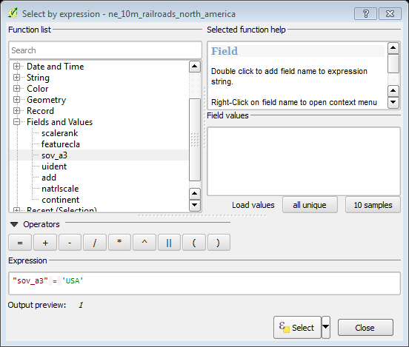
Step 2: In the main QGIS window, you will see that all lines that fall in USA are selected and appear in yellow.
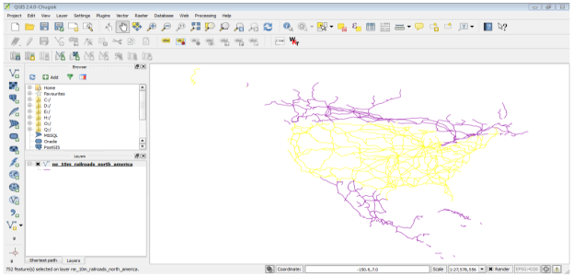

Step 3: Now let’s save our selection to a new shapefile. Right-click on the ne_10m_railroads_north_america layer and select “Save Selection As”. Click Browse and name the output file as “usa_railroads.shp”. We also want to change the CRS of the layer. Click on Browse next to CRS. Since we are interested in calculating length, let’s select an equidistance projection. Type “north america equ” in the Filter search box. In the results pane below, select North_America_Equidistant_Conic EPSG:102010 as the CRS. Click OK. In the Save vector layer as... dialog, check the Add saved file to map and click OK.
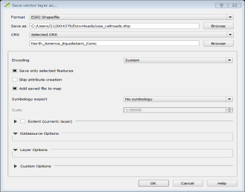
Step 4: A new layer “usa_railroads” is loaded in QGIS. Uncheck the box next to “ne_10m_railroads_north_america” layer to turn it off as we don’t need it anymore. Open attribute table of usa_railroads layer. Now it is time to add a column with length of each feature. Put the layer in editing mode by clicking on the Toggle editing button. Once in editing mode, click the “field calculator” button. In the Field Calculator, check Create a new field. Enter length_km as the Output field name. Choose Decimal number (real) as the Output field type. Change the output Precision to 2. In the Function list panel, find the $length under Geometry. Double-click it to add it to the Expression. Complete the expression as $length / 1000 because our layer CRS is in meters unit and we want the output in km. Click OK
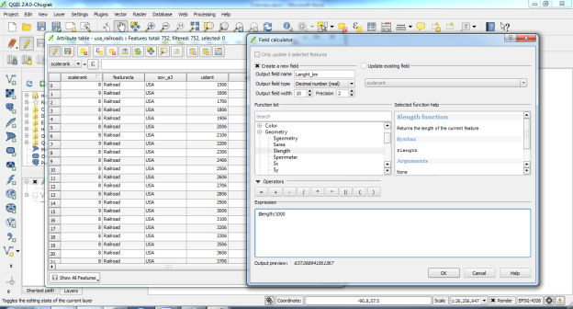
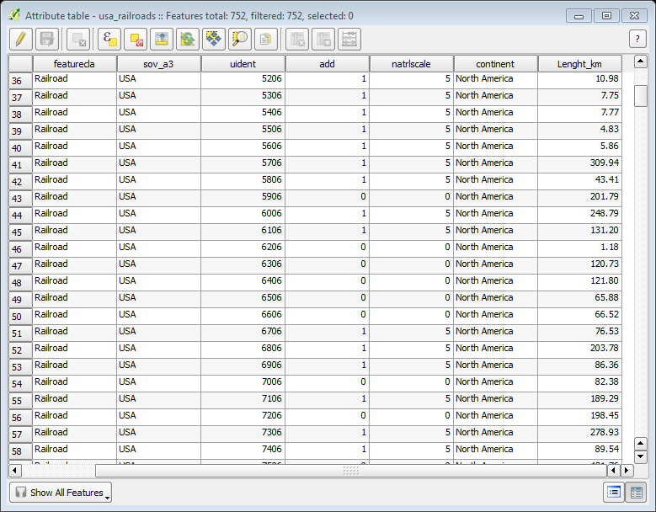
Step 5: Back in Attribute Table, you will see a new column length_km appear. Click the Toggle editing button to save the changes to the attribute table.
Step 6: Now that we have length of each individual line in our layer, we can easily add it all up and find the Total length. Go to Vector ‣ Analysis Tools ‣ Basic Statistics. Select the Input Vector layer as usa_railroads. Choose the Target field as length_km and click OK. You will see various statistics appear. The Sum value is the total length of the railroads that we are looking to find.
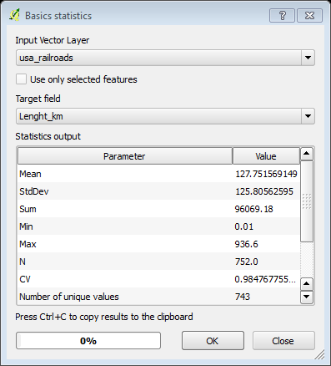
  - Basic Raster Styling and Analysis
QGIS has some basic analysis capabilities built-in by Raster Calculator. In this part, we will explore basics on using Raster Calculator and options available for styling raster. We will use population density grid data to find and visualize areas of the world that have seen dramatic population density change between year 1990 and 2000 and the areas of negative population density.
Other skills learned
- Selecting and loading multiple datasets in a single step in QGIS.
The areas of negative population density
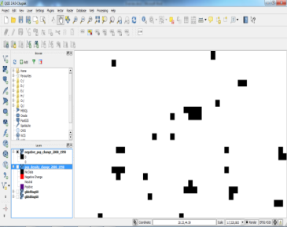

Step 1: Upload the “glds00ag60.asc” file to QGIS. The layer doesn’t have a CRS defined, and since the grids are in latitude and longitude, choose EPSG:4326 as the coordinate reference system. Repeat the process and select glds90ag60.asc grid as the layer to add. Now you will see both the rasters loaded in QGIS. The raster is rendered as in grayscale, where darker pixels indicate lower values and lighter pixels indicate higher values. Each pixel in the raster has a value assigned. This value is the population density for that grid. Activate “Identify Features” button and click anywhere on the raster to see the value of that pixel.
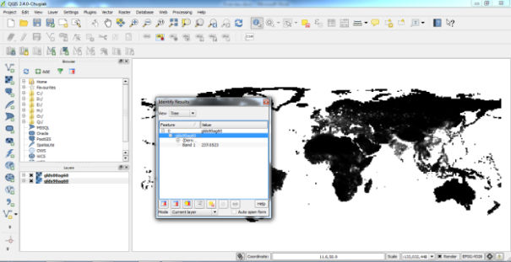
Step 2: To better visualize the pattern of population density, we would need to style it. Open properties of any layer. Under the Style tab, change the Render type to “Singleband pseudocolor”. Next, click Classify under Generate a new color map. You will see 5 new color values created. Click OK.
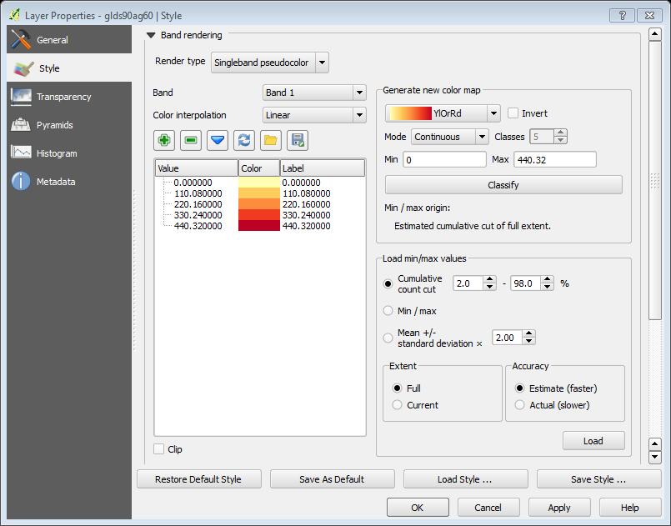
Step 3: Back in the QGIS Canvas, you will see a heatmap like rendering of the raster. Repeat the same process for the other raster as well
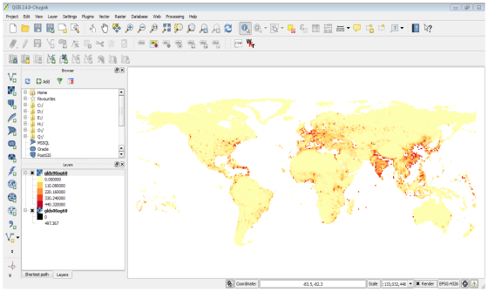

Step 4: For our analysis, we would like to find areas with largest population change between 1990 and 2000. The way to accomplish this is by finding the difference between each grid’s pixel values in both the layers. Select Raster ‣ Raster calculator. In the Raster bands section, select the layer by double-clicking on them. The bands are named after the raster name followed by @ and band number. Since each of our rasters has only 1 band, you will see only 1 entry per raster. The raster calculator can apply mathematical operations on the raster pixels. In this case we want to enter a simple formula to subtract the 1990 population density from 2000. Enter “glds00ag60@1 - glds90ag60@1” as the formula. Name your output layer as “pop_density_change_2000_1990.tif” and check the box next to Add result to project. Click OK
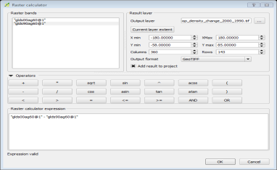
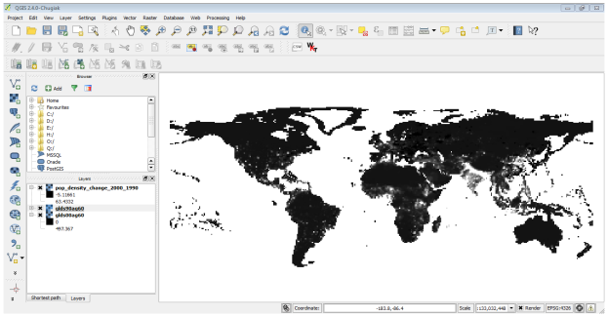
Step 5: Once the operation is complete, you will see the new layer load in QGIS. This grayscale visualization is useful, but we can create a much more informative output. Open properties of the “pop_density_change_2000_1990” layer.

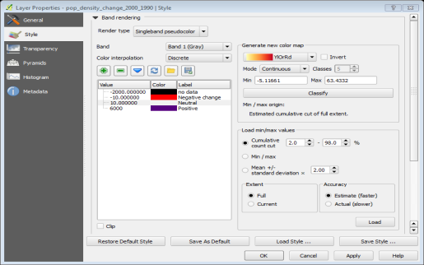
Step 6: We want to style the layer so pixel values in certain ranges get the same color. Select “Singleband pseudocolor” as the Render type under Band Rendering. Set the Color interpolation to Discrete. Click the Add entry button 4 times to create 4 unique classes. Click on an entry to change the values. The way color map works is that all values lower than the value entered will be given the color of that entry. Since the minmum value in our raster is just above -2000, we choose -2000 as the first entry. This will be for the No Data values. Enter the values and Labels for other entries as below and click OK

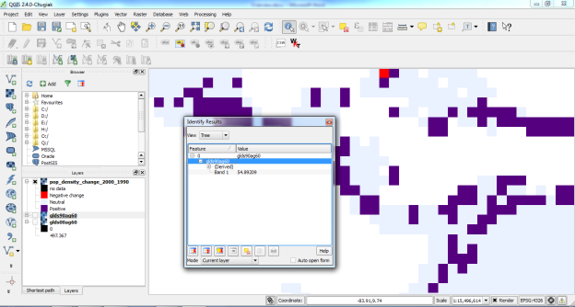
Step 7: Now you will see a much more powerful visualization where you can see areas which has seen positive and negative population density changes. Zoom In around Europe to explore the region in more detail. Select the Identify tool and click on the Red and Blue regions to verify that your styling rules worked as intended.
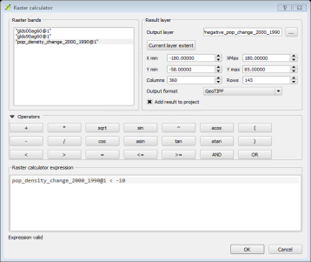
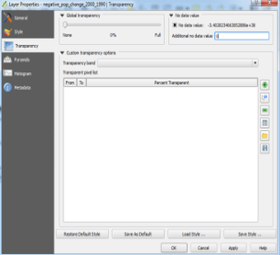
Step 8: To find areas with only negative population density change. Open Raster calculator. Enter the expression as shown below. Name the output layer as “negative_pop_change_2000_1990” and check the box next to Add result to project. Click OK. Once the new layer is loaded, right-click on it and select Properties. In the Transparency tab, add 0 as the Additional no data value. This setting will make the pixels with 0 values also transparent. Click OK.

  - Raster Mosaicing and Clipping
We will download some public domain raster data for Brazil and view it in QGIS. Next, we will merge these into a single mosaic and clip it using a country boundary to get a single seamless dataset for the country.
Other skills learned
- Searching and downloading near real-time public domain satellite imagery.
- Selecting a single feature from a vector layer and saving it to a new shapefile.
Step 1: Add Raster Layer on QGIS by selecting all the images and click open.

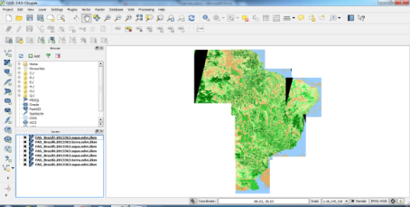

Step 2: Now let us create a single Mosaic image from all these individual images. Click on Raster ‣ Miscellaneous ‣ Merge. In the Merge dialog, click Select. Next to Input files and browse to the directory containing all the individual geotiffs. Keep holding Ctrl key and select all the subsets. Now click Select. Next to Output file and name the output as “Brazil_mosaic.tif”. At the bottom, check the box next to Load into canvas when finished. Click OK.
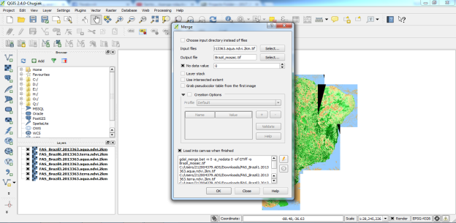
Step 3: You will get a pop-up message saying processing complete, once the mosaic is created and loaded to the QGIS Canvas. You will see that the individual images and now combined and mosaiced into a single layer. You can now turn off individual layers by un-checking the box next to them.
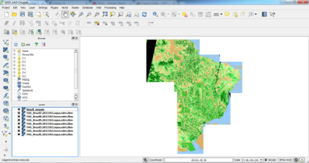
Step 4: Another Raster operation you can do is to subset or crop an image. We can use a polygon from a vector layer to crop the raster to the exact shape. Let’s load the country polygons shapefile we downloaded from Natural Earth. Add the ne_10m_admin_0_countries.zip file on QGIS. Once the vector layer is loaded, we want to select and extract the polygon for Brazil. Select the Select Single Feature tool from the toolbar
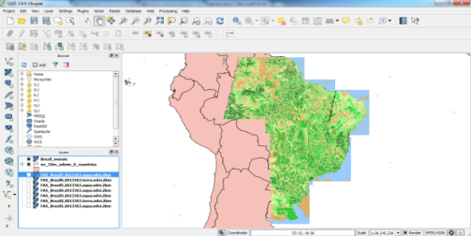
Step 5: Click anywhere on the Brazil polygon and it will be selected. Save the selected polygon as new shapefile. Name your output as “brazil_boundary.shp” and make sure Add saved file to map box is checked. Click OK. You will see the Brazil boundary polygon now loaded in QGIS.
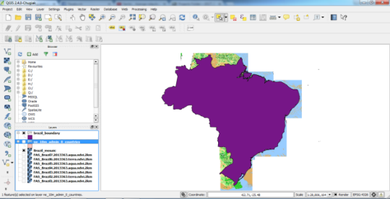
Step 6: Now go to Raster ‣ Extraction ‣ Clipper. Select the input file (raster) as Brazil_mosaic. Name the Output file as “Brazil_mosaic_clipped”. In the Clipping mode section, choose Mask layer. Select the newly created brazil_boundary as the mask layer. Check the box next to Load into canvas when finished. Click OK. The new cropped layer will be loaded into QGIS.
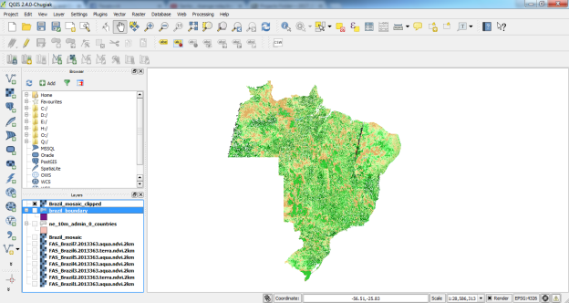
  - Working with Terrain Data
Terrain or elevation data is useful for many GIS Analysis and it is often used in maps. QGIS has good terrain processing capabilities built-in. In this tutorial, we will work through the steps to generate various products from elevation data such as contours, hill shade etc. The task is to create contours and hill shade map for area around Mt. Everest.
Other skills you will learn
- Searching and downloading freely available terrain data.
- Exporting a vector layer as KML and viewing it in Google Earth.
Step 1: Upload the “10n060e_20101117_gmted_mea300.tif” raster file on QGIS. You will see the terrain data rendered in the QGIS Canvas. Each pixel in the terrain raster represents the average elevation in meters at that location. The dark pixels represent areas with low altitude and lighter pixels represent areas with high altitude.
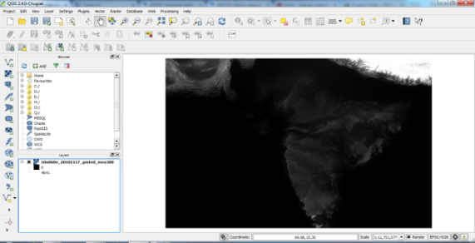
Step 2: Using Wikipedia, we find that the coordinates for Mt. Everest which is the area of interest. The coordinates are 27.9881° N, 86.9253° E. Paste 86.9253, 27.9881 at the bottom of QGIS window where it says Coordinate and press Enter. The viewport will be centered at this coordinate. To zoom in, enter 1:1000000 in the Scale field and press Enter. You will see the viewport zoom to the area around the Himalayas.
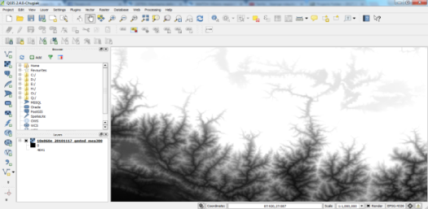
Step 3: We will now crop the raster to this area of interest. Select the Clipper tool from Raster ‣ Extraction ‣ Clipper. In the Clipper window, name your output file as ‘everest_gmted30.tif”. Select the Clipping mode as Extent. Keep the Clipper window open and switch to the main QGIS window. Hold your left mouse button and draw a rectangle covering the full canvas. Now back in the Clipper window, you will see the coordinates auto-populated from your selection. Make sure the Load into canvas when finished option is checked, and click OK.
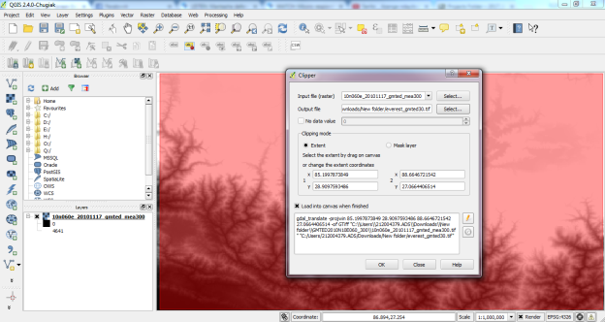
Step 4: A new layer will load in QGIS which covers only the area around Mt. Everest. To generate contours, we select the contour tool from Raster ‣ Extraction ‣ Contour. In the Contour dialog, select “everest_gmted30” as the Input file. Name the Output file for contour lines as “everest_countours.shp”. We will generate contour lines for 100m intervals, so put 100 as the Interval between contour lines. Also check the Attribute name option so elevation value will be recorded as attribute of each contour line. Click OK.
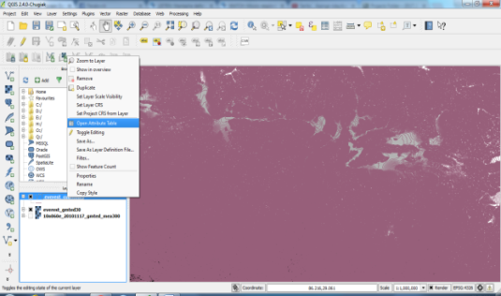

Step 5: To inspect the contours, right click on the contours layer and choose Open Attribute Table. You will see that each line feature has an attribute named ELEV. This is the height in metres that each line represents. Sort the values in descending order by double clicking on the column header. Here you will find the line representing the highest elevation in our data. Select the top row, and click on the Zoom to selection button. Switch to the main QGIS window. You will see the selected contour line highlighted in yellow. This is the area of the highest elevation in our dataset.
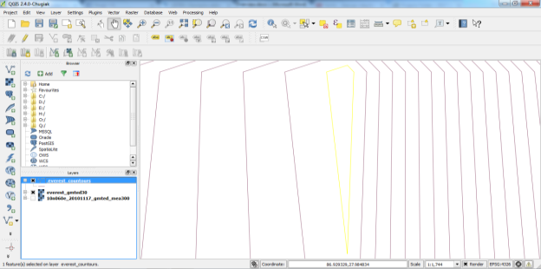
Step 6: To create a hillshade map from the raster. Select Raster, Analysis and DEM. In the DEM (Terrain Models) dialog, choose “everest_gmted30” as the Input file. Name the Output file as “everest_hillshade.tif”. Choose Hillshade as the Mode. Leave all other options as is. Make sure the Load into canvas when finished option is checked, and click OK. A raster layer will be loaded into QGIS. Click on the everest_hillshade layer and choose Zoom to Layer Extent. Now you will see the full extent of the hillshade raster. You can also visualize your contour layer and verify your analysis by exporting the contours layer as KML and viewing it in Google Earth. Right click on the contours layer, select Save as. Select Keyhole Markup Language [KML] as the Format. Name your output as “contours.kml” and click OK.
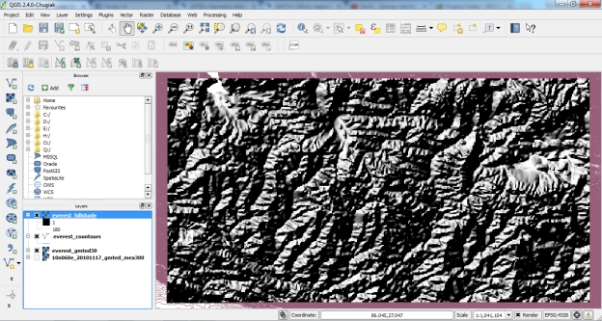
Step 7: Browse to the output file on your disk and double-click on it to open Google Earth.

  - Working with WMS Data
A popular standard for publishing maps online is called WMS (Web Map Service). This is a better choice for using reference layers as you get access to rich datasets in your GIS without the hassle of downloading or styling the data. In this part, we will load layers of Mineral Resources published by USGS.
Step 1: Open QGIS and go to on Layer ‣ Add WMS Layer. In the Layers tab, click on new. Name your connection. This is not the name of the layer but the name of service which is offering the WMS layer. A single service usually offers multiple layers that can be added to your project. The URL that you need to access a WMS layer is called Get Capabilities. When you access a WMS server with this parameter in the URL, it returns a list of layers available along with various metadata. In this case, name the connection as MRDATA USGS and the Get Capabilities URL as
http://mrdata.usgs.gov/services/ca?request=getcapabilities&service=WMS&version=1.1.1& . Click OK.
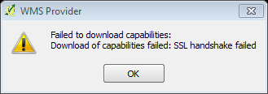
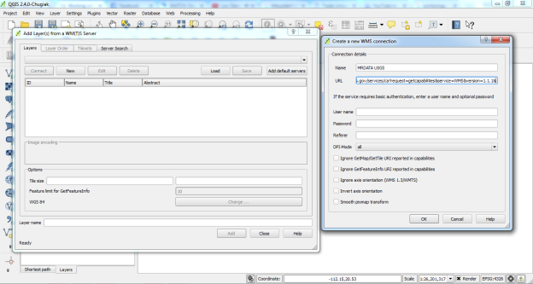

  - Georeferencing Topo Sheets and Scanned Maps
Step 1: Georeferencing in QGIS is done via the ‘Georeferencer GDAL’ plugin. Go to Plugins ‣ Manage and Install Plugins and enable the Georeferencer GDAL plugin in the Installed tab. Click on Raster ‣ Georeferencer ‣ Georeferencer to open the plugin. Now we will open our JPG image. Go to File ‣ Open Raster. Browse to the downloaded image of the scanned map and click Open. In the next screen, looking at our map image, the coordinates are in Lat/Long. There is no datum information given, so we have to assume an appropriate one. Since it is India and the map is quite old, we can bet the Everest 1830 datum would give us good results. You will see the image will be loaded on the top section.
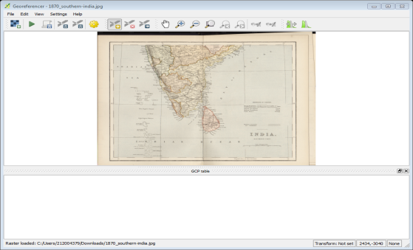
Step 2: You can use the zoom/pan controls in the toolbar to learn more about the map. Now we need to assign coordinates to some points on this map. If you look closely, you will see coordinate grid with markings. Using this grid, you can determine the X and Y coordinates of the points where the grids intersect. Click on Add Point in the toolbar. In the pop-up window, enter the coordinates. Remember that X=longitude and Y=latitude. Click OK.
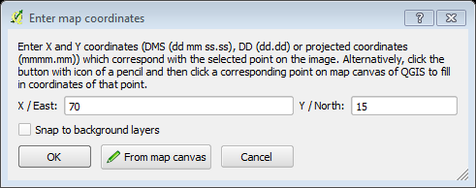
Step 3: Similarly, add at least 4 GCPs covering the entire image. The more points you have, the more accurate your image is registered to the target coordinates.
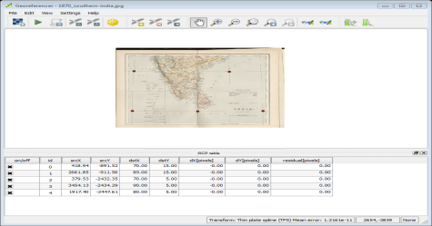
Step 4: Once the process finishes, you will see the georeferenced layer loaded in QGIS.
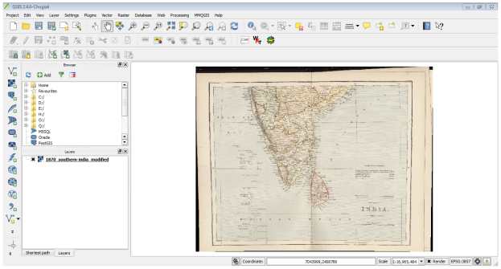
Step 5: The georeferencing is now complete. But as always, it’s a good practice to verify your work. How do we check if our georeferencing is accurate? In this case, load the country boundaries shapefile from a trusted source like the Natural Earth dataset and compare them. You will notice they match up pretty nicely.
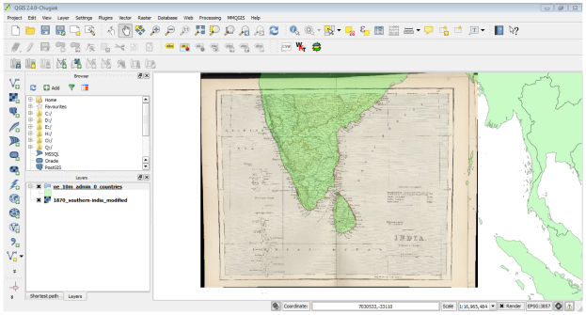
  - Digitizing Map Data
QGIS has powerful on-screen digitizing and editing capabilities that we will explore in this part of the lesson. We will use a raster topographic map and create several vector layers representing features around a park.
Other skills you will learn
- Building pyramids for large raster datasets to speed up zoom and pan operations.
Step 1: Add Raster Layer by uploading the downloaded “BX24_GeoTifv1-02.tif”. Before we start, we need to set default Digitizing Options. Go to Settings ‣ Options. Select the Digitizing tab in the Options dialog. Set the Default snap mode to “To vertex and segment”. This will allow you to snap to the nearest vertex or line segment. I also prefer to set the Default snapping tolerance and Search radius for vertex edits in pixels instead of map units. This will ensure that the snapping distance remains constant regardless of zoom level. Click OK.
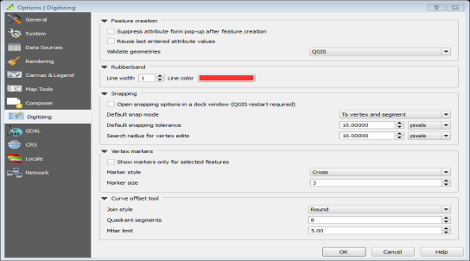
Step 2: Click on Layer from the tool bar‣ New ‣ New Spatialite Layer. In the New Spatialite Layer dialog, click the button and save a new spatialite database named “nztopo.sqlite”. Choose the Layer name as Roads and select Line as the Type. The base topographic map is in the EPSG:2193 - NZGD 2000 CRS, so we can select the same for our roads layer. Check the Create an autoincrementing primary key box. This will create a field called pkuid in the attribute table and assign a unique numeric id automatically to each feature. Enter “Name” as the name of the attribute in the New attribute section and click Add to attribute list. Similarly create a new attribute Class of the type Text data. Click OK. Once the layer is loaded, click the Toggle Editing button to put the layer in editing mode.
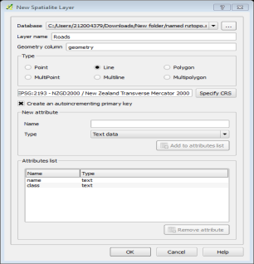

Step 3: Click the Add feature button. Click on the map canvas to add a new vertex. Add new vertices along the road feature. Once you have digitized a road segment, right-click to end the feature. After you right-click to end the feature, you will get a pop-up dialog called Attributes. Here you can enter attributes of the newly created feature. Since the pkuid is an auto-incrementing field, you will not be able to enter a value manually. Leave it blank and enter the road name as it appears on the topo map. Optionally, assign a Road Class value as well. Click OK. The default style of the new line layer is a thin line. Open properties and choose a thicker line style such as Primary from the predefined styles. Click OK. Click Save Layer Edits to commit the new feature to disk. Before we digitize remaining roads, it is important to update some other settings that are important to create an error free layer. Go to Settings ‣ Snapping Options and check the two boxes on the bottom right.
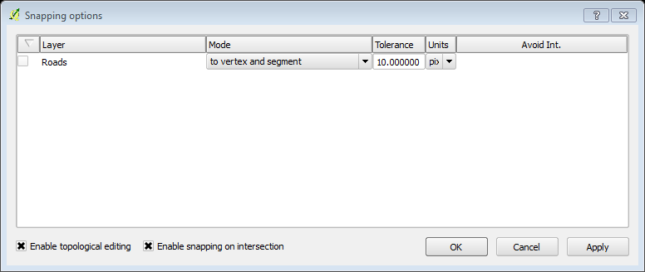
Step 4: Now you can click Add feature button and digitize other roads around the park. Make sure to click Save Edits after you add a new feature to save your work. A useful tool to help you with digitizing is the Node Tool. Click the Node Tool button. Once the node tool is activated, click on any feature to show the vertices. Click on any vertex to select it. The vertex will change the color once it is selected. Now you can click and drag your mouse to move the vertex. This is useful when you want to make adjustments after the feature is created. You can also delete a selected vertex by clicking the Delete key. Once you have finished digitizing all the roads, click the Toggle Editing button.
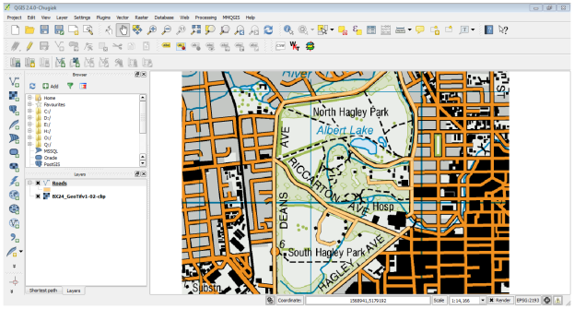
Step 5: Now we will create a polygon layer representing the park boundaries. Go to Layer ‣ New ‣ New Spatialite Layer.... Select the nztopo.sqlite database from the dropdown list. Name the new layer as Parks. Select Polygon as the Type. Create a new attribute called Name. Click OK
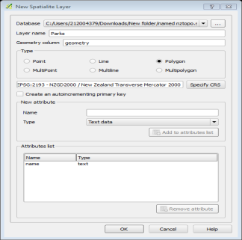
Step 6: Click the Add feature button and click on the map canvas to add a polygon vertex. Digitize the polygon representing the park. Make sure you snap to the roads vertices so there are no gaps between the park polygons and road lines. Right-click to finish the polygon. Enter the park name in the Attributes pop-up. Polygon layers offer another very useful setting called Avoid intersections of new polygons. Go to Settings ‣ Snapping Options.... Check the box in the Avoid Int column in the row for the Parks layer. Click OK. Now click on Add feature to add a polygon. With the Avoid intersections of new polygons, you will be able quickly digitize a new polygon without worrying about snapping exactly to the neighboring polygons.
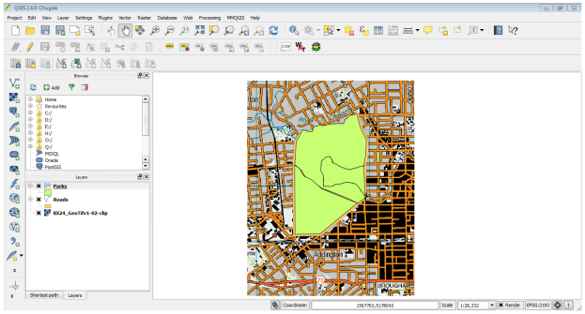
Step 7: Now it is time to digitize a buildings layer. Once the Buildings layer is added, turn off the Parks and Roads layer so the base topo map is visible. Select the Buildings layer and click Toggle Editing. We will use a plugin called Rectangles Ovals Digitizing to help with this task. Once the Rectangles Ovals Digitizing plugin is installed, you will see a new toolbar appear above the canvas. Click the Rectangle from center. Click at the center of the building and drag the mouse to draw a vertical rectangle. We need to rotate this rectangle to match the image on the topo map. The rotate tool is available in the Advanced Digitizing toolbar. Enable the Advanced Digitizing toolbar. Click the Rotate Feature(s) button. Use the Select Single feature tool to select the polygon that you want to rotate. Click exactly on that crosshairs and drag the mouse while holding the left-click button. A preview of the rotated feature will appear. Save the layer edits and click Toggle Editing once you finish digitizing all buildings.
