- INTERMEDIATE GIS OPERATIONS
  - Performing Table Joins
This operation is known as a Table Join and this lesson covers how to carry out table joins in QGIS. We use a shapefile of census tracts for California and population data table from US Census Bureau to create a population map for california.
Other skills learned
- Creating .csvt files to indicate column data types in a CSV file.
- Loading CSV files that do not contain any geometry in QGIS
Step 1: The first task is to load the census tracts shapefile. The census tracts will be loaded into QGIS.
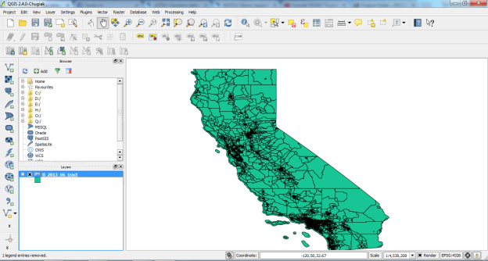
Step 2: To join a table with this shapefile, we need a unique and common attribute for each feature. In this case, the GEOID field is a unique identifier for each tract and can be used to link this shapefile with any other table containing the same ID. Open the CSV file ca_tracts_pop.csv in a text editor. You will notice that each row of the file contains information about a tract along with the unique identifier we saw in the previous step. Note that this field is called GEO.id2 in the CSV. You will also note that the D001 column has population value for each of the census tract. We could import this csv file without any further action and it would be imported. But, the default type of each column would be a String (text). That is ok except for the D001 field which contains numbers for the population. To tell QGIS to import the field as a number, we need to create a sidecar file with a .csvt extension. This file will have only 1 row specifying data types for each column. Save this file as “ca_tracts_pop.csvt” in the same directory as the original .csv file.
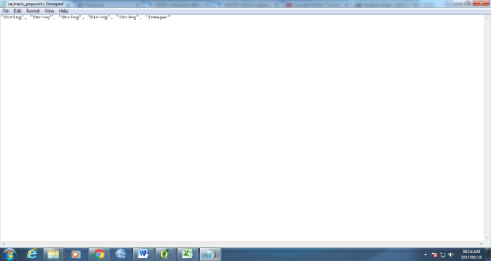
Step 3: Importing the CSV file to QGIS. Go to Layer ‣ Add Delimited Text Layer. Browse to the folder containing the CSV file and select it. Make sure you have selected File format as CSV (comma separated values). Since we are importing this as a table, we must specify that our file contains no geometry. Select the No geometry (attribute only table) option. Click OK.
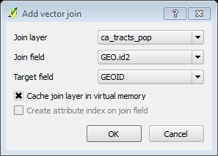

Step 4: The CSV will now be imported as a table to QGIS. Open the “tl_2013_06_tract” layer’s properties. In the Layer Properties dialog, select the Joins tab. Click on the + button at the bottom to create a new table join. In the Add vector join dialog, select “ca_tracts_pop” as the Join layer. Next we have to select the field with unique ids in both the shapefile and the CSV. Select GEO.id2 and GEOID as the Join field and Target field respectively. Click OK.
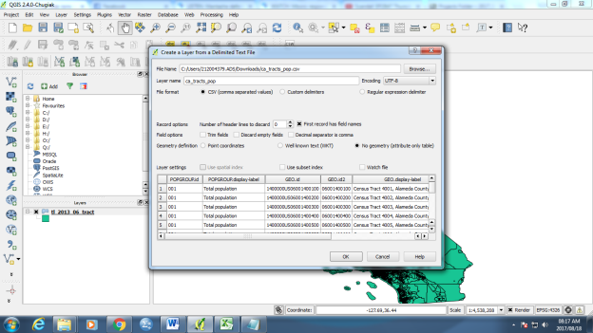
Step 5: Return to the main QGIS window. At this point, the fields from the CSV file are joined with the shapefile. To assign different color to each census tract feature based on the population count, go to properties of “tl_2013_06_tract” layer and on style select graduated. Select “ca_tracts_pop_D001” as the Column. Select a color ramp of your liking from the Color ramp drop-down. In the Mode, select Quantile (Equal Count). Next click Classify. Click OK. You will now see a nice visualization of the census tracts as styled using population values. Use the Zoom in tool to select a smaller area from the layer.
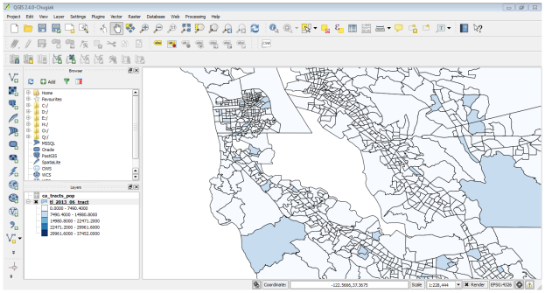
  - Performing Spatial Joins
In QGIS, this functionality is available through the Join Attributes by Location tool. We will use 2 layers - A shapefile of burough boundaries of New York city and another shapefile of nursing home locations in New York city. We will use spatial join technique to find the total nursing home capacity for each of the buroughs.
Other skills learned
- Deleting columns from the attribute table of a layer
Step 1: Upload the downloaded zip file “nybb_12c.zip”and “OEM_NursingHomes_001.zip” files on QGIS. Once all the layers are loaded on QGIS, open attribute table of the OEM_NursingHomes_001 layer. Since our task is to calculate the total nursing home capacity for each borough, we can use the attribute Capacity which can join to the boundaries layer. Go to Vector ‣ Data Mangement Tools ‣ Join attributes by location. The Target vector layer is the one we want to add the attributes to. In our case, this will be the boroughs boundary nybb layer. The Join vector layer will be the nursing homes OEM_NursingHomes_001 layer. As we want to sum the capacity of nursing homes, select Take summary of intersecting features and choose Sum. Name the output file as “nyc_borough_join.shp”. In the Output table select keep all records.
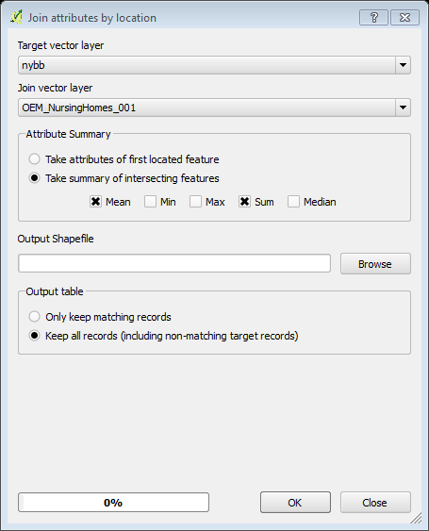
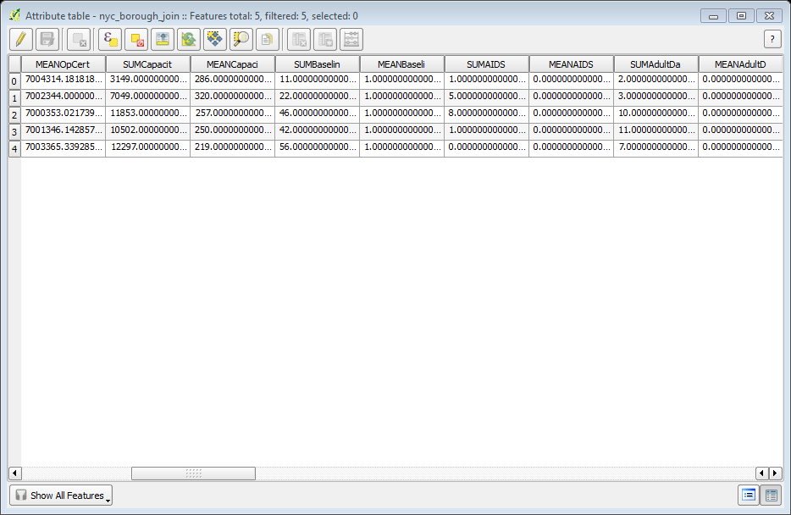
Step 2. Once the process finishes, select Yes when asked if you want to add the layer to TOC. The new layer nyc_borough_join would have the features from nybb layer along with spatially joined attributes from OEM_NursingHomes_001 layer. Open attribute table of the layer. You will see a column SUMCapacit in the attribute table. This is the sum of the Capacity attribute for the nursing homes that fall within each borough feature.

Step 3: This is the answer we are looking for. But there are extra columns that we do not need in our output. Let’s clean up our output. Click on the Toggle editing button and then the Delete column button. Press Control-A to select all columns in the Delete Attributes dialog. Next hold the Control key and de-select the columns you want to keep. Click OK.

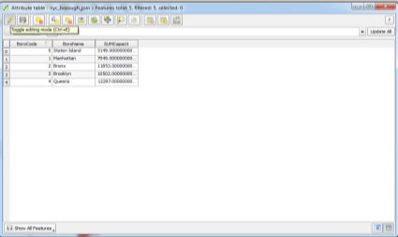
Step 4: Back in the QGIS Canvas, use the Identify tool to verify that the output file has the desired attributes for each borough feature.
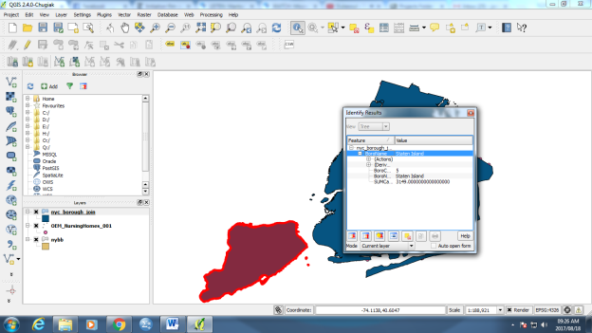
  - Points in Polygon Analysis
When you have a polygon layer and a point layer - and want to know how many or which of the points fall within the bounds of each polygon, you can use this method of analysis. Given the locations of all known significant earthquakes, we will try to find out which country has had the highest number of earthquakes.
Step 1: Open Layer ‣ Add Delimited Text Layer and browse to the downloaded signif.txt file. Since this is a tab-delimited file, choose Tab as the File format. The X field and Y field would be auto-populated. Click OK. As the earthquake dataset has Latitude/Longitude coordinates, choose WGS 84 EPSG: 436 as the CRS in the Coordinate Reference System Selector dialog.
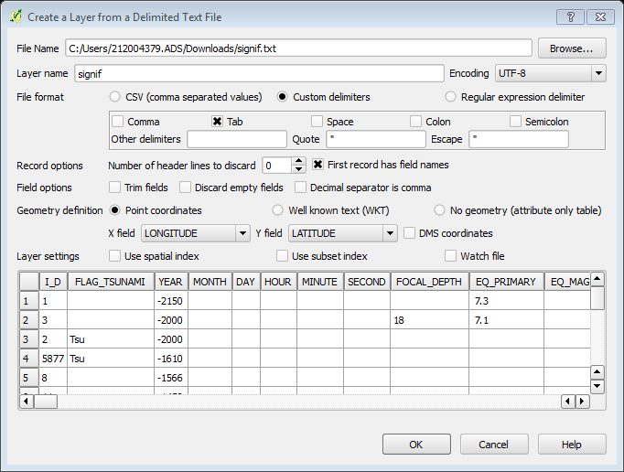
Step 2: The earthquake point layer would now be loaded and displayed in QGIS. Let’s also open the Countries layer. Add the downloaded “ne_10m_admin_0_countries.zip” file. Select the ne_10m_admin_0_countries.shp as the layer in the Select layers to add dialog. Click on Vector ‣ Analysis Tools ‣ Point in Polygon. In the pop-up window, select the polygon layer and point layer respectively. Name the output layer as “earthquake_per_coutry.shp” and Click OK.
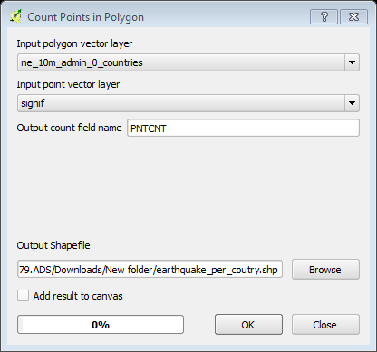

Step 3: You will see a new layer is added to the table of content. Open the attribute table. In the attribute table, you will notice a new field named PNTCNT. This is the count of number of points from the earthquakes layer that fall within each polygon. To get our answer, we can simply sort the table by PNTCNT field and the country with highest count will be our answer. Click 2-times on the PNTCNT column to get it sorted in descending order. Click on the first row to select it and close the Attribute Table.
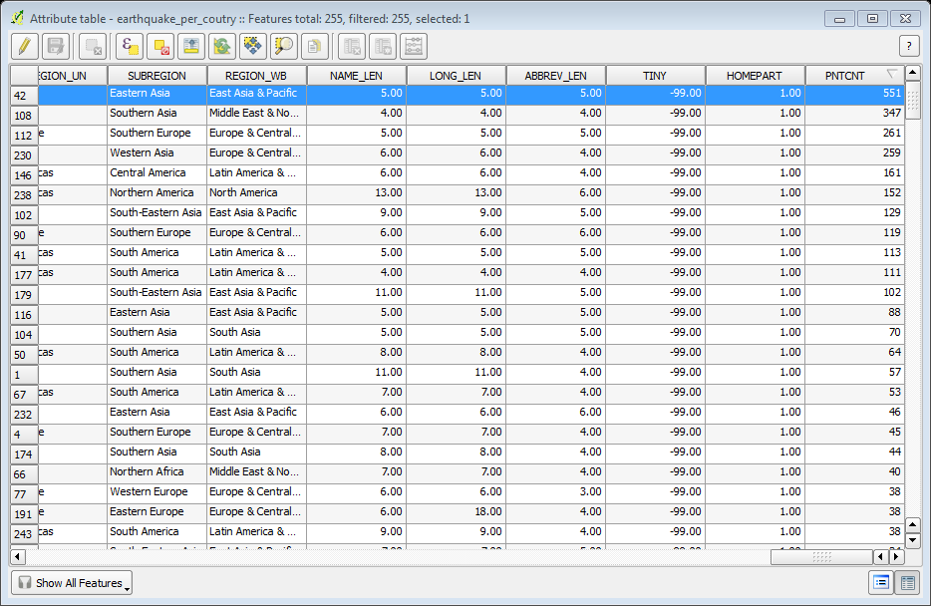

Step 4: Back in the main QGIS window, you will see one feature highlighted in yellow. This is the feature linked to the selected row in the attribute table which had the highest number of points. Select the Identify tool and click on that polygon. You can see that the country with the highest number of significant earthquakes is China.
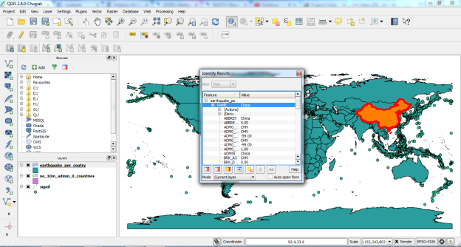
  - Performing Spatial Queries
In QGIS, this functionality is available via the Spatial Query plugin. We will be working with 2 datasets; a lines layer representing rivers and a point layer representing cities. The task is to run a spatial query to find all cities that are within 10 kms of a river.
Other skills you will learn
- Opening .zip files directly in QGIS.
- Choosing an appropriate projection and re-projecting vector data.
- Creating buffers.
- Selecting features using SQL-like expressions.
- Coverting a shpefile to a KML file.
- Validating your results using Google Earth
Step 1: After downloading the data, upload it to QGIS by clicking on both zip files. Click Open. You will be asked to choose a layer from the zip archive. Click OK. You will see both the shapefiles now loaded in QGIS.
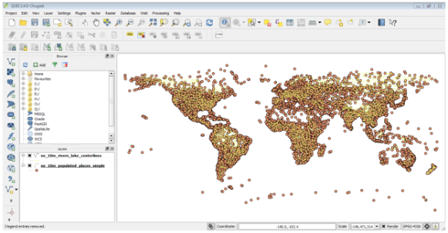
Step 2: We will be created buffers around the point and line layers. The Buffer geoprocessing tool in QGIS uses layer units to calculate buffer distances. The layers we have are in Geographic Coordinate Reference System (CRS) with the unit of degrees, therefore needs to be changed because we want to use meters or kilometers. To reproject the layers we will create a new shapefile for “10m_populated_places_simple” and “ne_10m_rivers_lake_centerlines” layer and change the CRS to Azimuthal Equidistant projection. Now you will have 4 layers in your Layers Panel. Uncheck the boxes next to the original layers to display only the re-projected layers. The re-projected layers are still being shown in the Geographic CRS because of a setting. Let’s turn that off. Click on the Project Properties button. This setting can also be accessed from Project ‣ Project Properties and check the box next to Enable on-the-fly CRS transformation. Click OK

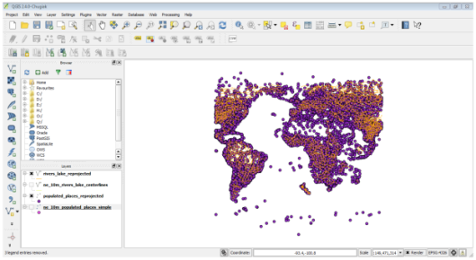

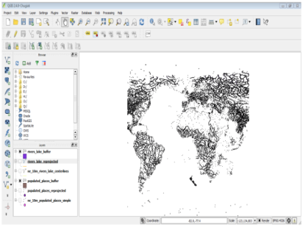
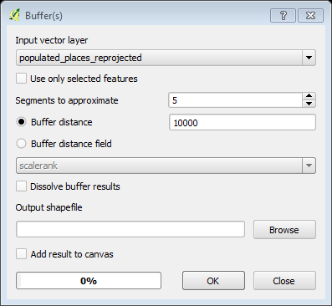
Step 3: Back in the main QGIS window, right-click on any one of the re-projected layers and select Zoom to Layer Extent. Now you will see the data in the layer’s CRS. We will now create buffers for both the datasets. Click Vector ‣ Geoprocessing Tools ‣ Buffer. In the Buffer tool, select “populated_places_reprojected” layer as Input. Enter the buffer distance as 10000. Note that we want a buffer of 10kms and since the CRS units are meters, we need to enter 10,000. Enter the output file name as “populated_places_buffer.shp.” Click OK. Repeat the same buffer process for the “rivers_lake_reprojected” layer and create an output file named “rivers_lake_buffer.shp”.

Step 4: The rivers_lake_buffer contains features that are both rivers as well as lakes. Our analysis calls for using only river features, so we will run a query to select only river features. Right-click on the rivers_lake_buffer layer and select Open Attribute Table. You will see that the featurecla attribute contains the information we can use to select the river features. Click on Select features using an expression button. Enter the expression “featurecla” = “River” and click Select and then click Close to back to the main QGIS window. Now we are ready to perform the spatial query. You need to enable the Spatial Query plugin to use this functionality. Once enabled, go to Vector ‣ Spatial Query ‣ Spatial Query
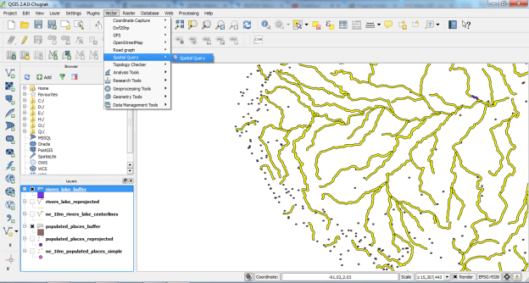
Step 5: For our query, we want to select features from the buffered places that intersect with the buffered river lines. Make sure the checkbox next to selected geometries is checked. This is to ensure the query uses only river features that we selected previously. Click Apply. Once the query is complete, you will see a new section named “Selected features”. Click on the Create layer with selected button. A new layer will be added to the Layers Panel. Click Close.
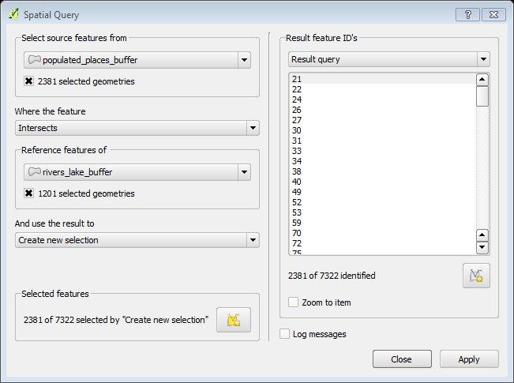
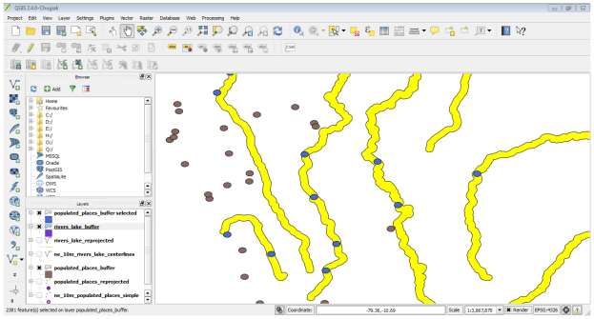
Step 6: If you Zoom-in to any area you will notice that the new layer contains only the features that intersect with river buffers. It is also critical to verify the results to ensure the analysis is not flawed. One way to verify the results is to export this layer as a KML file and load it up in Google Earth. You can check if the areas you found really are within 10kms of a river. Right-click the layer and Save As to create a KML and change the CRS to WGS84 Name your KML as “cities_near_river.kml”.
Step 7: Open Google Earth and verify that the cities represented by these buffers are indeed close to rivers.
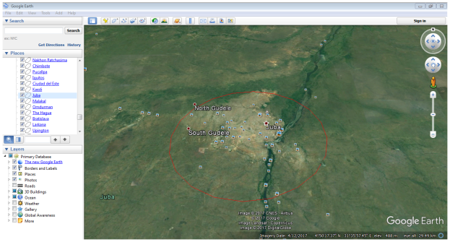
  - Creating Heatmaps
Heatmaps are one of the best visualization tools for dense point data. Heatmaps are used to easily identify find clusters where there is a high concentration of activity. They are also useful for doing cluster analysis or hotspot analysis. We will work with a dataset of crime locations in Surrey, UK for the year 2011 and find crime hotspots in the county.
Other skills learned
- How to perform Hot Spot or Cluster analysis on dense point data.
Step 1: To start, import the downloaded CSV file into QGIS. Go to Raster ‣ Heat map ‣ Heat map. In the Heat map Plugin dialog, choose “crime_heatmap” as the name out the Output raster. Enter 1000 meters as the Radius. Check the Advanced so we can specify the output size of our heat map. Enter 2000 as Rows value. The Columns value will update automatically. Click OK to start the heat map creation process.

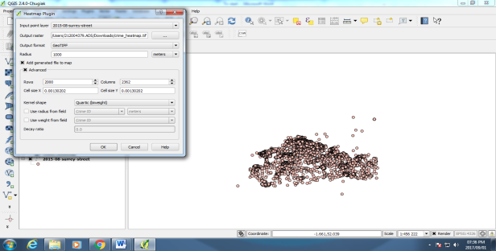
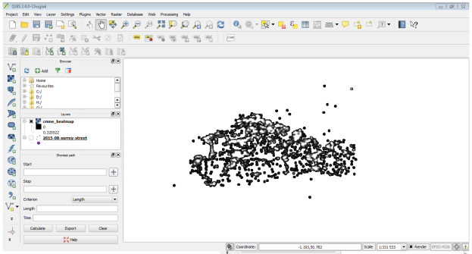
Step 2: Once the processing is finished, you will see a grayscale layer called “crime_heatmap” loaded into the canvas. Uncheck the “2015-08-surrey-street” layer
Step 3: Open properties, in the Style tab button, select “Singleband pseudocolor” as the Render type. Next, under the section Load min/max values select the Estimate (faster) as the Accuracy and click Load. In the section Generate new color map, select YlOrRd (Yellow-Orange-Red) as the color ramp, and click Classify. Click OK.

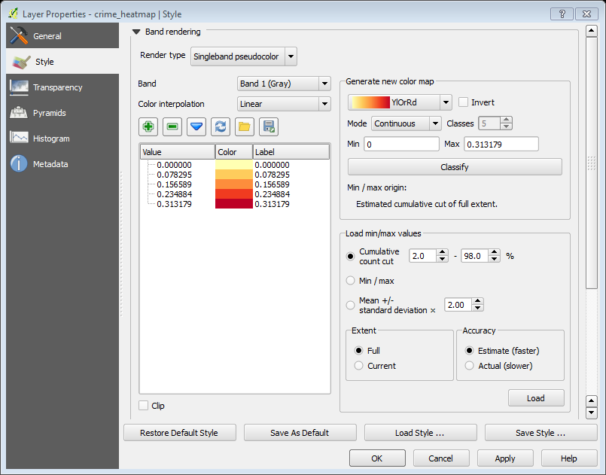
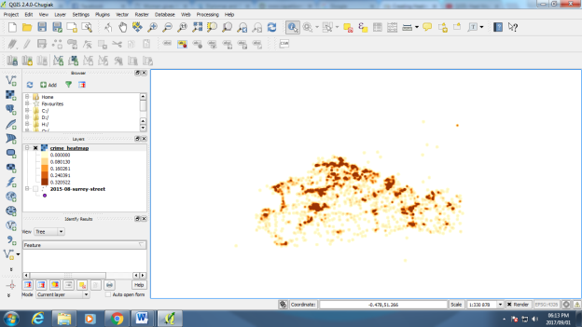
Step 4: Now you will see a more appealing heat map like rendering of the layer. You can select the Identify tool and click on any pixel of the heat map. You will see the pixel value in the resulting pop-up. This pixel-value is a measure of how many points from the source layer are contained within the specified radius (in our case - 1000m) around the pixel.
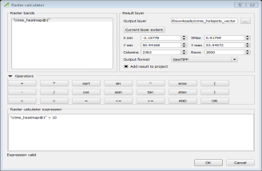
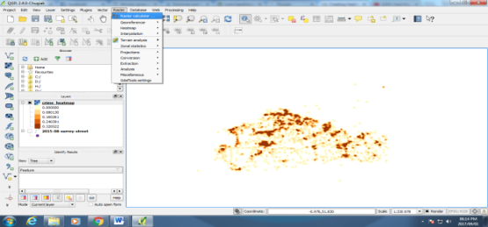
Step 5: To identify the hotspots where there is high-concentration of points. Go to Raster ‣ Raster Calculator. You will have to decide on a threshold value first. All pixel values above that threshold will be considered to be in a cluster. Let’s use a value of 10 for this data. In Raster calculator dialog, name the output layer as “crime_hotspots_vector”. Double-click on crime_heatmap@1 under the Raster bands section and it will be added to the Raster calculator expression text area. Complete the expression as shown below. Check the box next to Add result to project and OK

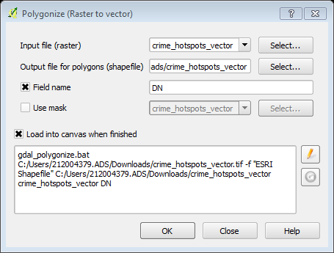
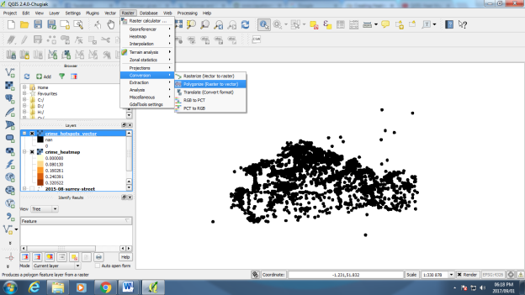
Step 6: A new layer called “crime_hotspots” will be added to QGIS. This layer has pixels with values of either 0 or 1. All pixels in the input layer where the pixel value was larger than 10 now have a value of 1 and all remaining pixels are 0. Click on Raster ‣ Conversion ‣ Polygonize (Raster to Vector). Name the output file as “crime_hotspots_vector”. Check the box next to Field name as well as Load into canvas when finished. Click Ok
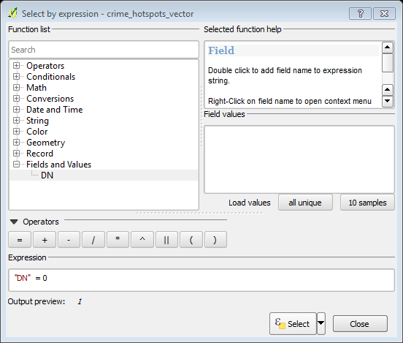
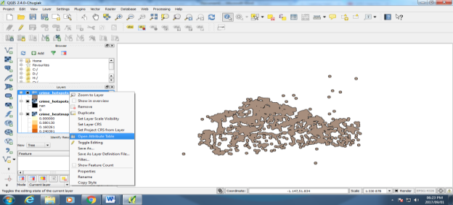
The layers contain clusters with both 0 and 1 value. Let’s filter out the 0 values, so we get the clusters of hotspots. Right click on the layer and select Open Attribute Table. In the attribute table, click on the select feature using an expression. Enter the expression as shown below and click Select. Next, click on Close. In the main attribute table window, you will see some features highlighted. These are the features that matched our query. Click the Toggle editing mode button in the toolbar and then click the Delete selected features button. Once the selected features are deleted, click the Save Edits button and then Toggle editing mode again to put the layer in read-only mode. Close the attribute table window.

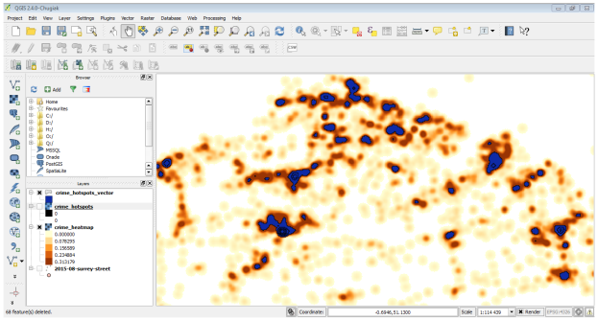
The final layer crime_hotspots_vector contains the cluster e

