- QUICKSTART
  - Making a Map
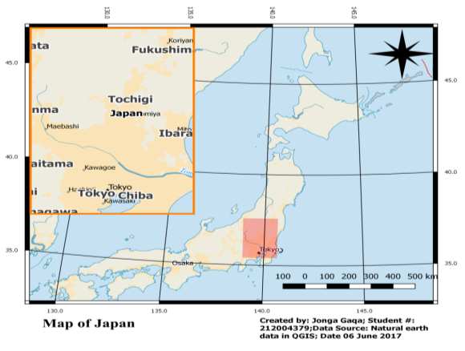
QGIS has a powerful tool called Print Composer that allows you to take your GIS layers and package them to create maps. This excise shows how to create a map by creating map of Japan. The use of standard map elements like map inset, grids, north arrow, scale bar and labels is shown. The data that was used for this excise is “Natural Earth Quick Start Kit data” which was downloaded from Natural Earth data source.

Figure 1: This is the final product of the map of Japan that was created using the following simple steps below.

Step 1: Download and extract the Natural Earth Quick Start Kit data. Open QGIS. In QGIS, click on Project and Open Project. Browse to where you have extracted the natural earth data and click open.
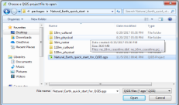
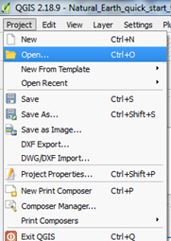
Step 2: There will be a lot of layers in the table of content and a styled world map in the QGIS canvas. However, we are interested in Japan. Therefore we zoom to Japan by Clicking the Zoom button form the tool bar and draw a rectangle around Japan to zoom to the area.
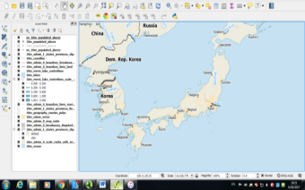
1

Note! There is a need to choose an appropriate projection to make a map suitable for printing. The dataset used in here is in Geographic Coordinate System (GCS) where the units are degrees and this is not appropriate for a map where you want the distances to be in kilometers. Therefore, Universal Transverse Mercator (UTM) is a decent choice for a projected coordinate system. For this excise, the UTM Zone 54N was used. Click the CRS Status button at the bottom-right of the QGIS window.
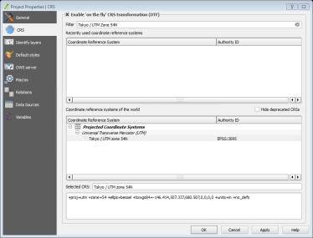
Step 3: Check the Enable on-the-fly CRS Transformation box. Type Tokyo UTM zone54n in the Filter search box. Once you see the results, select Tokyo / UTM Zone 54N - EPSG: 3095. Click Apply.

2

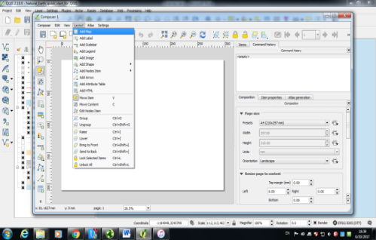
Step 4: Now we can start to assemble our map. Go to Project ‣ New Print Composer. You will be prompted to enter a title for the composer. You can leave it empty and click Ok. In the Print Composer window, click on Zoom full to display the full extent of the Layout. Now we would have to bring the map view that we see in the QGIS Canvas to the composer. Go to Layout ‣ Add Map.

Step 5: Once the Add Map button is active, hold the left mouse button and drag a rectangle where you want to insert the map. You will see that the rectangle window will be rendered with the map from the main QGIS canvas. The rendered map may not be covering the full extent of our interest area. Select Layout ‣ Move item content to pan the map in the window and center it in the composer. Now we will add a map inset that shows a zoomed in view for the Tokyo area.
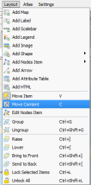
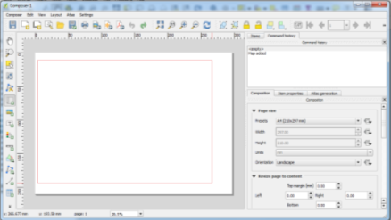

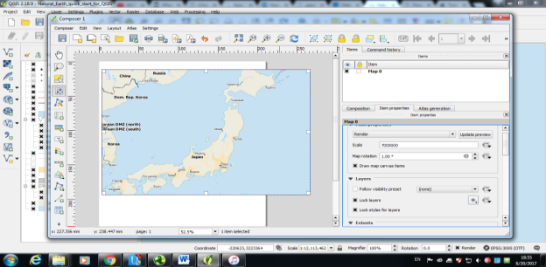
Step 6: Let us adjust the zoom level for the given map. Click on the Item Properties tab and enter 7000000 for Scale value. Now we will add a map inset that shows a zoomed in view for the Tokyo area. Before we make any changes to the layers in the main QGIS window, check the Lock layers for map item and Lock layer styles for map item boxes. This will ensure that if we turn off some layers or change their styles, this view will not change.
Step 7: Switch to the main QGIS window. Use the Zoom In button to zoom to the area around Tokyo. Switch the Print Composer window. Go to Layout ‣ Add Map. Drag a rectangle at the place where you want to add the map inset. You will now notice that we have 2 map objects in the Print Composer. Select the Map 1 object that we just added from the Items panel. Select the Item properties tab. Scroll down to the Frame panel and check the box next to it. You can change the color and thickness of the frame border so it is easy to distinguish against the map background
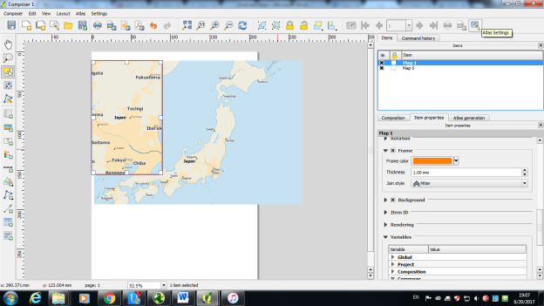
Step 8: One neat feature of the Print Composer is that it can automatically highlight the area from the main map which is represented in our inset. Select the Map 0 object from the Items panel. In the Item properties tab, scroll down to the Overviews section. Click the Add a new overview button. Select Map 1 as the Map Frame. What this is telling the Print Composer is that it must highlight our current object Map 0 with the extent of the map shown in the Map 1 object.

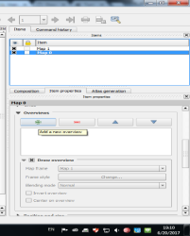
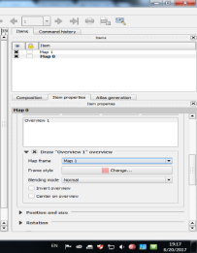

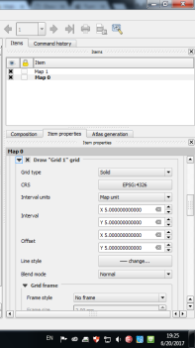
Step 21: To add a grid and zebra border to the main map, select the Map 0 object from the Items panel. In the Item properties tab, scroll down to the Grids section. Click the Add a new grid button. it is more common and useful to display grid lines in degrees. We can select a different CRS for the grid. Click on the change button next to CRS. In the Coordinate Reference System Selector dialog, enter 4326 in the Filter box. From the results, select the WGS84 EPSG: 4326 as the CRS. Click OK. Scroll down to the Grid frame section and select a frame style that suits your taste. Also check the Draw coordinates box. Adjust the Distance to map frame till the coordinates are legible. Change the Coordinate precision to 1 so the coordinates are displayed only up to the first decimal.

Step 9: Adding a North Arrow to the map. Click Layout ‣ Add Image. Holding your left mouse button, draw a rectangle on the top-right corner of the map canvas. On the right-hand panel, click on the Item Properties tab and expand the Search directories section and select the North Arrow image of your liking.
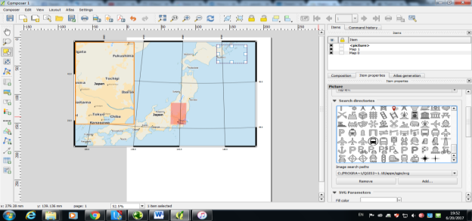
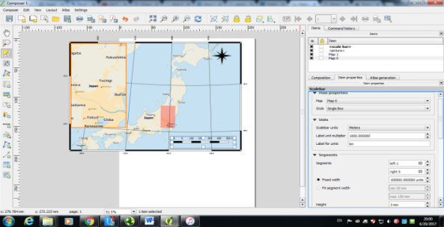
Step 10: Adding a Scale Bar. Click on Layout ‣ Add Scalebar. Click on the layout where you want the scale bar to appear. In the Item Properties tab, make sure you have chosen the correct map element for which to display the scalebar. Choose the Style that fit your requirement. In the Segments panel, you can adjust the number of segments and their size.

Step 11: Adding Labels. To add labels Click on Layout ‣ Add Label. Click on the map and draw a box where the label should be. In the Item Properties tab, expand the Label section and enter the text as shown below. Similarly add another label to add the data and software credits. Once done with labeling, you can export it as Image, PDF or SVG. In excise, it was exported as an image by Clicking “Composer ‣ Export as Image”.
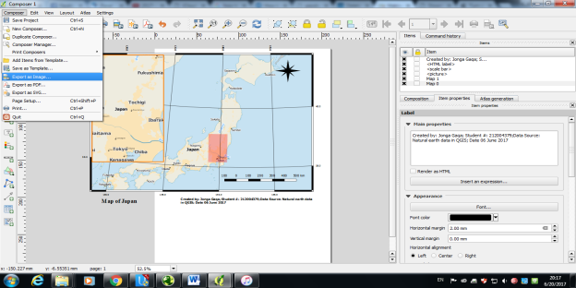

  - Working with Attributes
In the previous part we have learned how to open QGIS, download data, how to use tools from tool bar and upload data on QGIS. GIS data has two parts, features and attributes. Attributes are structured data about each feature. This excise shows how to view the attributes and do basic queries on them in QGIS. The task is to query and find all the capital cities in the world that have a population greater than 1,000,000. Note; what has been learned from previous part is not repeated on next part of this excise.
Other skills Learned
- Select features from a layer using expressions.
- Deselect features from a layer using the Attributes toolbar.
- Using Query Builder to show a subset of features from a layer.

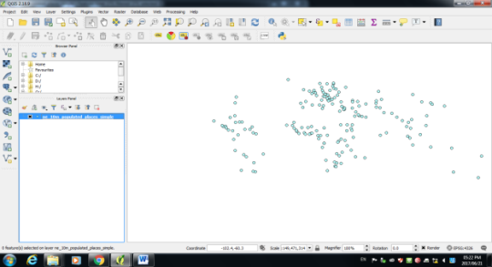
Capital cities in the world that have a population greater than 1,000,000

Below are the steps that were followed to achieve the result of the task above
Step 1: Download the data and upload it on QGIS. You do not need to unzip the file. QGIS has the ability to read zip files directly. The selected layer will now be loaded in QGIS and you will see many points representing the populated places of the world.
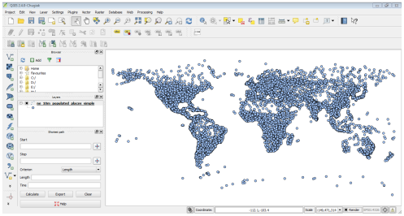
Step 2: Right-click the layer and select Open Attribute Table and the table window will be displayed. We are interested in the population of each feature, so pop_max is the field we are looking for. You can click twice on the field header to sort the column in descending order.
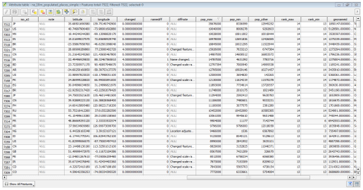
Step 3: Performing query on attributes. QGIS uses SQL-like expressions to perform queries. Click Select features using an expression. In the “Select By Expression” window, expand the Fields and Values section and double-click the “pop_max” label. You will notice that it is added to the expression section at the bottom.
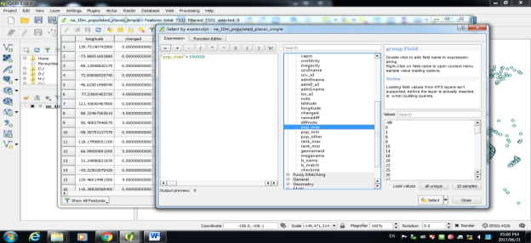
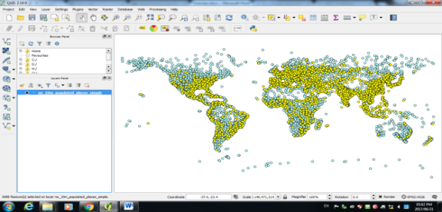
Step 4: From the main QGIS window you will notice that a subset of points is now rendered in yellow. This is the result of our query and you are seeing all places from the dataset that have the pop_max attribute value greater than 1,000,000

Step 5: The goal for this exercise is to find the places that are country capitals. The field containing this data is adm0cap. The value 1 indicates that the place is a capital. We can add this criteria to our previous expression using the “and” operator. Let’s refine our query to select only those places which are capitals. Click on the Select feature using an expression button in the attribute table and enter the expression as below and click Select and then Close.
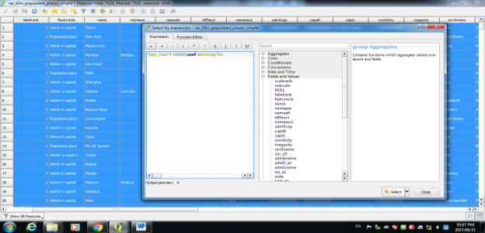
"pop_max" > 1000000 and "adm0cap" = 1

Step 6: Return to the main QGIS window. Now you will see a smaller subset of the points selected. This is the result of the second query and shows all places from the dataset that are country capitals as well as have population greater than 1,000,000. If we wanted to do some further analysis on this subset of data, we can make this selection persistent. Right-click the ne_10m_populated_places_simple layer and select Properties. In the General tab, scroll down to the Feature subset section. Click Query Builder. Enter the same expression you had entered earlier and click OK.
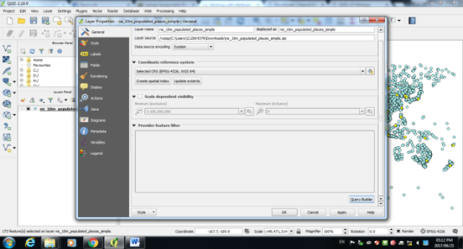
Step 7: Back in the main QGIS window, you will see rest of the points disappear. You may now perform any other analysis on this layer and only the features that match our expression will be used. You will notice that the points still appear in yellow. This is because they are still selected. Find the Deselect Features from All Layers button under the Attributes toolbar and click on it. You will see that the points are now de-selected and rendered in their original color.
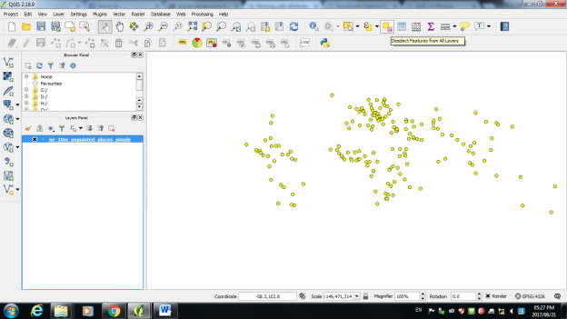
  - Importing Spreadsheets or CSV files
Many times the GIS data comes in a table or an Excel spreadsheet. Also, if you have list latitude or longitude coordinates, you can easily import this data in your GIS project. For this excise, we will be importing a text file of earthquake data to QGIS
Imported text file of earthquake data displayed in the QGIS canvas.
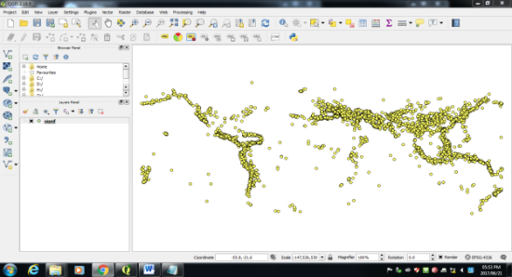

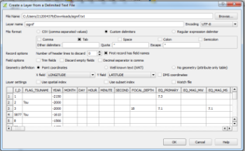
Step 1: Open QGIS. Click on Layers ‣ Add Delimited Text Layer. In the Create a Layer from a Delimited Text File dialog, click on Browse and specify the path to the text file you downloaded. In the File format section, select Custom delimiters and check Tab. The Geometry definition secction will be auto-populated if it finds a suitable X and Y coordinate fields. In our case they are LONGITUDE and LATITUDE. You may change it if the import selects the wrong fields. Click OK.

Step 2: You may see some errors displayed in the next dialog. The erros in this file are mainly due to missing X or Y fields. You may examine these errors and fix the problems in your source file. For this tutorial, you may ignore these errors. Next, a Coordinate Reference System Selector will ask you to select a coordinate reference system. Since the earthquake coordinates are in latitudes and longitudes, you should select WGS 84. Click OK.
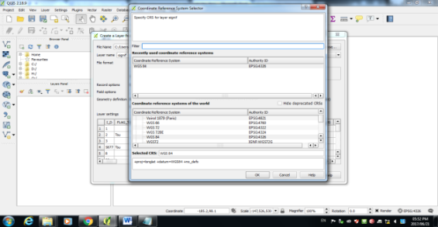
  - Using Plugins
    - Core Plugins
Core plugins are already part of the standard QGIS installation. To use these, you just need to enable them.
Step 1: Open QGIS. Click on Plugins ‣ Manage and Install Plugins, to open the Plugin Manager dialog. Check on the checkbox next to Spatial Query Plugin. This will enable the plugin and you will be able to use it. One thing to note is that plugins have the ability to insert menu items at various locations and create new panels and toolbars. To find the newly enabled tools look in the plugin description. Here the description says Category: Vector. That indicates that the plugin would be found under the Vector menu once enabled. Click Close.
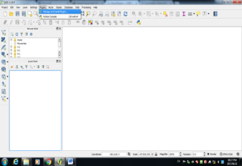
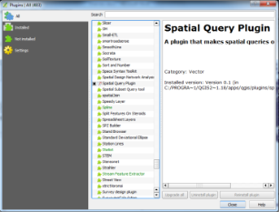

Step 2: Now that the Spatial Query Plugin is enabled, you can go to the Vector ‣ Spatial Query to use the functionality added by the plugin.
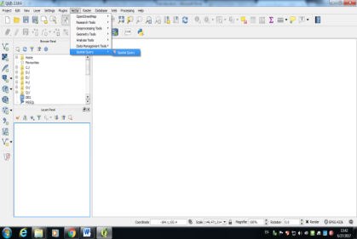
    - External Plugins
External plugins are available in the QGIS Plugins Repository and need to be installed by the users before using them. An easy way to browse and install these plugins is by using the Plugin Manager tool
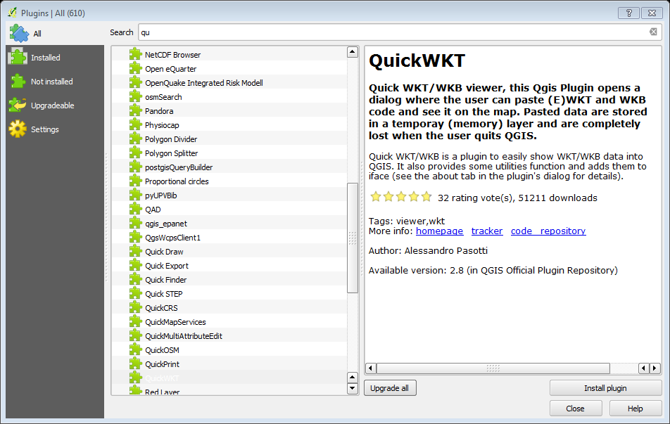
Step 1: Before you can install external plugins you need to be online and configure your internet setting on QGIS. Once that is done when you Click on Plugins ‣ Manage and Install Plugins. The external plugins will download automatically. You can now search for the plugin you want to use and install it.

    - Experimental Plugins
Now you know how to install and find an External Plugin in QGIS. Let’s explore some advanced options. Sometimes you are looking for a specific plugin, but cannot find it in the Get more tab. It maybe because the plugin is marked “Experimental”. Here is how to install experimental plugins.
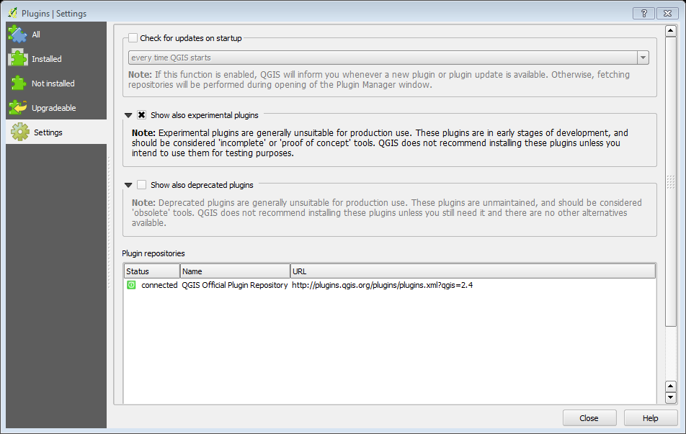
Step 1: Open Plugin Manager by Plugins ‣ Manage and Install Plugins. Click on the Settings tab. You will see an option called Show also experimental plugins. Click the checkbox next to it, to enable it

    - Searching and Downloading Open Street Map Data
Getting high quality data is essential for any GIS task. One great resource for free and openly licensed data is OpenStreetMap(OSM) . Getting access to OSM data in a GIS format is integrated in QGIS. This part shows the process for searching, downloading and using OSM data in QGIS.

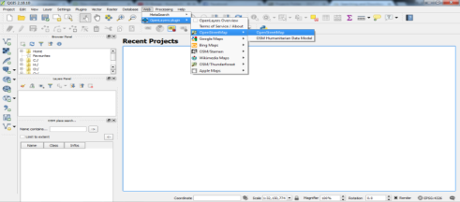
Step 1: We will use 2 plugins to accomplish the task. Make sure you have installed OSM Place Search and Open Layers plugins. Above it has been demonstrated on how to install and use plugins. The OSM Place Search plugin will install itself as a Panel in QGIS. You will see a new panel titled OSM place search in QGIS.

Note: QGIS could not load OSM Data therefore the task was could not be completed.

